Predictive Analysis for Enhanced Power Production in Combined-Cycle Plants

**especially How it is going to help us with this data on Energy Production**

In a combined-cycle power plant, electricity is generated using a combination of gas turbines, steam turbines, and heat recovery steam generators (HRSG). These plants are designed to optimize energy generation by efficiently utilizing exhaust heat to produce additional power.The process typically starts with gas turbines burning fuel to generate electricity. The hot exhaust gases produced by the gas turbines are then used to create steam in the heat recovery steam generators. This steam is directed to drive a steam turbine, which generates additional electricity. The combination of these cycles—gas turbine and steam turbine—creates a highly efficient power generation process.To model the energy generated in such a plant, various factors need to be considered. Variables such as exhaust vacuum, ambient temperature, pressure, and possibly other environmental conditions play crucial roles in determining the efficiency and output of the turbines. By analyzing historical data and employing statistical modeling techniques, it's possible to create a mathematical model that relates these variables to the amount of energy produced by the plant.

**Temperature (in degrees Celsius)**: This measures the heat or coldness of the environment or a specific system. In an energy production context, it's crucial for understanding how temperature affects the efficiency of power generation equipment like turbines or engines.

In an industrial or power generation context, temperatures can vary significantly. However, typical ranges might be:

**Room temperature**: 20-25 degrees Celsius

**Operational temperatures in power plants or industrial settings**: 100-1000 degrees Celsius depending on the equipment and process.

**Exhaust Vacuum (in cm Hg):** This measures the pressure differential between the exhaust system and the atmosphere. In power plants, it's relevant to combustion engines or turbines where the exhaust pressure can impact the efficiency of energy conversion.

This can vary greatly depending on the specific system and its design. In a typical setup:

**Low vacuum**: Around 50-200 cm Hg

**Higher vacuum:** Closer to 0 cm Hg (absolute pressure)

**Ambient Pressure (in millibar)**: This measures the pressure of the surrounding atmosphere. It's vital in power generation, especially for systems utilizing steam turbines where high-pressure steam is used to turn turbines and generate electricity.

Normal atmospheric pressure at sea level is around 1013 millibars. However, this can vary:

**Range at sea level**: 900-1100 millibars

**Variations with altitude:** Decreases by about 1 millibar for every 10-meter increase in altitude.

**Relative Humidity (in percentage)**: This measures the moisture content in the air relative to the maximum amount of moisture the air can hold at that temperature. It's important in energy production processes involving combustion, as high humidity can affect the combustion efficiency and equipment performance.

Relative humidity can vary widely based on location and weather conditions:

**Desert regions:** 10-30%

**Coastal regions:** 60-80%

**Indoor environments:** 30-60%

**Energy Production (in MW, net hourly electrical energy output)**: This measures the net electrical energy produced per hour. It's the final outcome of the entire energy generation process, influenced by all the aforementioned parameters along with other factors such as fuel quality, equipment efficiency, and operational conditions.

The net hourly electrical energy output can vary greatly depending on the capacity and type of power plant. Ranges might be:

**Small-scale plants:** 1-100 MW

**Large-scale utility plants**: 100-1000+ MW

***Power Generation Equipment:***

Gas Turbine: The measurements of temperature, exhaust vacuum, and energy production could correspond to a gas turbine. These turbines use high-temperature gases and exhaust to generate power. The exhaust vacuum indicates the pressure differential post-energy extraction.

Steam Turbine: Similar measurements might be from a steam turbine system. The temperature could represent steam temperatures, ambient pressure could relate to the boiler pressure, and energy production signifies the power output.

Boiler System: These measurements could also be from a boiler system where temperature, pressure, and humidity are critical parameters for steam generation.

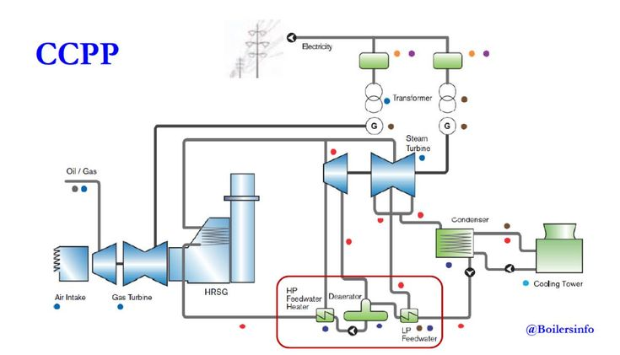

So, as per the ranges for every are approximate and can significantly differ based on the specific industry, technology used, geographical location, and operational conditions.Predictive values in energy production are incredibly valuable for decision-making and operational management. Once you have these predicted values, there are several actions and strategies you can implement:

**Optimized Operations**:

**Load Forecasting**: Use predicted energy demand to optimize the scheduling and operation of power generation units. Adjust production to meet expected demand efficiently, reducing waste and maximizing resource utilization.

**Maintenance Planning**:

**Predictive Maintenance**: Use predicted equipment temperatures, pressure variations, and performance metrics to schedule maintenance. This prevents unexpected failures, minimizes downtime, and extends equipment lifespan.

**Resource Allocation**:

**Fuel Management**: Forecast fuel consumption to ensure adequate reserves are available. Plan and procure resources based on predicted usage, optimizing inventory and reducing costs.

**Renewable Energy Integration**: Use predictions of renewable energy availability (solar irradiance, wind speed) to plan and optimize the integration of these sources into the grid, maximizing their contribution to energy production.